Draft 2021 data call including data reporting format

OSPAR Common indicators: Instructions for filling in the OSPAR Marine Seals Data Reporting Format

IMPORTANT – PLEASE READ
Since the last OSPAR seal data call in 2016, some changes have been made to the data format and to the data submission method. These changes have been necessary to store new variables not included in 2016 but which are in the new OSPAR Biodiversity Database hosted and maintained by ICES. Please ensure you read all the guidance below:

- Always use the latest version of the reporting sheets, which will be delivered as part of the OSPAR data call. Do not use old versions.
- Please do not use any thousand separators (commas, apostrophes, or blanks) in number fields.
- Latest guidance and formats will always be available on http://biodiversity.ices.dk

CONTACTS
Content Contact: MarineMammals@jncc.gov.uk
Please contact MarineMammals@jncc.gov.uk if you have any enquiries about what data to include in your submission. Please reference OSPAR SEALS in the subject bar.
Technical contact: accessions@ices.dk
Please contact accessions@ices.dk if you encounter problems submitting your data online or need any additional codes.
Latest reporting format: http://biodiversity.ices.dk

1. Data Use
Contracting Parties will report data (as specified below) that will enable an assessment, of two Biodiversity Common Indicators:
M3 - Seal abundance and distribution (harbour and grey seal)
M5 - Grey seal pup production
These indicators have been adopted by some Contracting Parties as part of their cooperation with other EU Member States in implementing the Marine Strategy Framework Directive (MSFD - 2008/56/EC).
The data will also contribute to OSPAR achieving its thematic strategy on Biological Diversity and Ecosystems; in particular with the “regional, coordinated development of monitoring and assessment of marine biodiversity and ecosystem functioning”.
Marine mammals, including seals, are top predators, and comprise an important part of marine biodiversity. Seals are most reliably counted when they are hauled out on land, and counts are usually conducted during breeding or moulting seasons. The current monitoring does not account for distribution at sea. Further information on the assessments and required spatial scale is provided below. Current and known plans for monitoring harbour and grey seals are detailed in Annex 1 to Annex 3. A glossary of key terms is in Annex 4.
M3 - Seal abundance and distribution (harbour and grey seal)
The distribution and abundance assessments for both grey and harbour seal (M3) use counts of hauled out animals, as well as location of haulouts surveyed.
- Harbour seal moult counts – all counts of harbour seals by haulout unit (see next section for description of unit) and Assessment Unit made during their moulting period for that year.
- Harbour seal pup counts – where available, all counts of harbour seals by haulout unit and Assessment Unit made during their pupping period for that year
- Grey seal moult counts – where available, all counts of grey seals by haulout unit and Assessment Unit made during their moulting period for that year.
- Grey seal August counts – where available, all counts by haulout unit and Assessment Unit of grey seals made during the harbour seal moult surveys.
M5 - Grey seal pup production
For the assessment of grey seal pup production, counts of hauled out grey seal pups during the pupping/breeding season are used, as well as location of breeding colonies surveyed:
- Grey seal pup counts – all counts of grey seal pups by breeding unit divided into categories if used (e.g. dead, alive, whitecoat, moulted).
- Grey seal pup production – estimates of total pup production if available.

Spatial scale (count locations)
The count data are requested on two spatial scales depending on the indicator:
- Haulout units (required) and by AU (if available) for M3 harbour and grey seal abundance and distribution.
- Breeding unit (required) and by AU (if available) for M5 grey seal pups.
Assessments of distribution of hauled out seals of both species, harbour seal abundance and grey seal pup production are made at the scale of the assessment units (AUs) in Figure 1. Grey seals are highly mobile and range over large distances, so their abundance will be assessed at a larger scale with a single AU covering
OSPAR regions I (Arctic Waters), II (Greater North Sea) and III (Celtic Seas), but for the purpose of analysis, data are requested at the scale of the grey seal pup production units (Figure 1).

The finer resolution (haulout unit or breeding unit) will allow investigation of changes in harbour seal distribution (of haulout units) and in grey seal distribution (of haulout units and breeding units). Each finer resolution data entry should be ascribed to one of the relevant AUs (see Figure 1).
To generate the M3 distribution indicator, submitted data will need to be converted into gridded presence/absence data covering OSPAR regions I, II and III. All data should be provided by the scale of a haulout unit, or on a 5 x 5 km grid. To minimise the processing required to submit data, haulout unit is an arbitrary unit which can represent part of what may biologically considered a haulout (e.g. a count associated with the location of an individual photograph), a haul out or a cluster of haulouts. Haulout units for which the spatial extent is < c. 2.5 km can be input as Points. Polygons should reflect the approximate extent of haulouts/clusters and can be used instead of points for any haulout unit but must be used for any haulout units which are >2.5 km in spatial extent. Haulout units do not need to be consistent across surveys, but every haulout unit must be described in Table 4. Haulout/breeding unit description. A new haulout unit in Table 4 should be added if the location of the associated point or the extent of the associated polygon has changed since the last survey – this is important for the distribution element of the indicator. For example, for a particular haulout (e.g. Pandora Sands), there may be two associated haulout units, one for surveys in prior to 2000, and one for post 2000 due to a movement of the sandbank.
For M5 assessments, distributional change is not examined in the same way and thus data should be provided by individual breeding unit. ‘Breeding unit’ refers to a grey seal breeding colony(ies) on which pup counts and pup production estimates are provided. Irrespective of spatial extent, such colonies can be represented by points or polygons and must be identifiable (i.e. consistent) between surveys.
Unless data are provided on a 5 x 5 km grid, survey effort data must also be provided for the M3 indicator (Table 5. Seal_Survey_Effort) so areas of no seals can be distinguished from areas from areas of no survey. Such data should be provided per survey round (e.g. one row for each moult survey conducted in a year). Survey data should be indicated as a polygon. Effort data is not necessary for M5 breeding units because breeding units stay constant through time and thus survey effort will be indicated by the presence of a count (e.g. 0). All survey IDs should be added to Table 5. Seal_Survey_Effort whether spatial information is required or not. Where spatial information is not required (for M5 grey seal pup data and for M3 data supplied on a 5 x 5 km grid) ‘breeding units’ or ‘5km grid’ can be selected under data_resolution and survey effort containing presence and absence data can be selected under data_type.

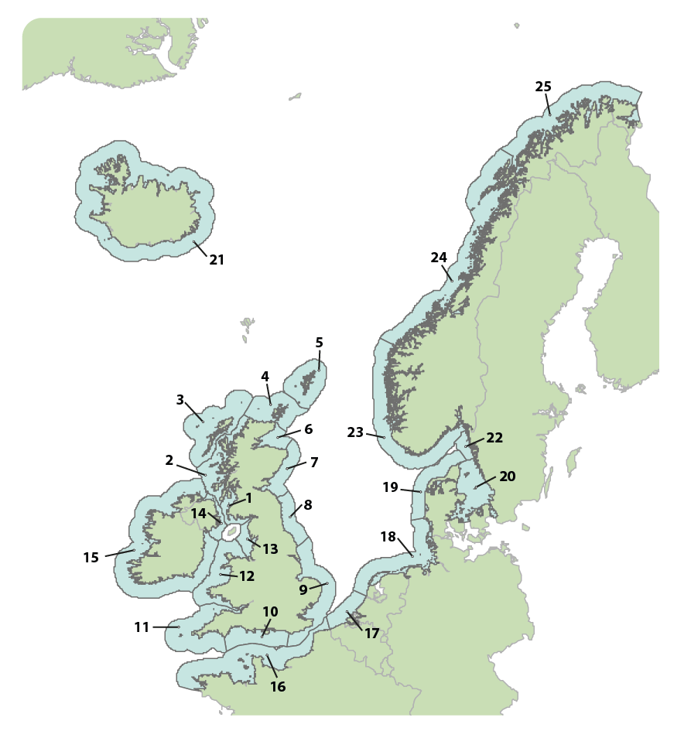
Figure 1. Assessment units (AUs) for distribution for both species indicators, harbour seal abundance and grey seal pup production. [Grey seal abundance will be assessed at a larger scale with a single AU covering
OSPAR regions I, II and III, but for the purpose of analysis, data are requested at the scale of the units presented in this figure.] More information on the AUs are available as a shapefile: here: https://odims.ospar.org/layers/geonode:ospar_assessment_areas_2021_02_001
1. Southwest Scotland, 2. West Scotland, 3. Western Isles, 4. North Coast & Orkney, 5. Shetland, 6. Moray Firth, 7. East Scotland, 8. Northeast England, 9. Southeast England, 10. South England, 11. Southwest England, 12. Wales, 13. Northwest England, 14. Northern Ireland, 15. Ireland, 16. French North Sea & Channel Coast, 17. Belgium coast and Dutch Delta, 18.Wadden Sea, 19. Limfjorden, 20. Kattegat, 21. Iceland, 22. Skagerrak, 23. Norway MA1 (Lista – Stad), 24. Norway MA2 (Stad – Lofoten), 25. Norway MA3 (Vesterålen – Varanger).

2. Reporting Format 2021
To report data on seals, please use the latest version of the document “OSPAR_Seals_reporting_format.xlsm” available from http://ices.dk/data/data-portals/Pages/Biodiversity.aspx.
The data required are described in detail in Tables 1-6 below. For code and drop-down references please refer to the vocabulary lists that accompany the MS Excel data entry sheets:
- File_information
- Seal_AU_totals
- Haulout_Breeding_Unit_Abundance
- Unit_description (for haulout / breeding units)
- Seal_survey_effort
- Seal_survey_programme_metadata

3. Submitting data online
Each Contracting Party should submit their data to the ICES data portal. Data submission deadline is 28-Feb-2021.
Step 1: The Excel sheets should be downloaded via http://ices.dk/data/data-portals/Pages/Biodiversity.aspx and filled out with data.
Step 2: When the data sheets are filled out, the <Export data to XML> button on the ‘Export_data’ worksheet should be pressed to produce the xml data file (see Figure 2).
Note: the Excel file contains macros that are used for transforming the worksheets to the XML data format for uploading. Generally, you should only enable macros from a trusted source, please ensure you download the Excel file from ICES directly to be sure of a clean, virus free file.
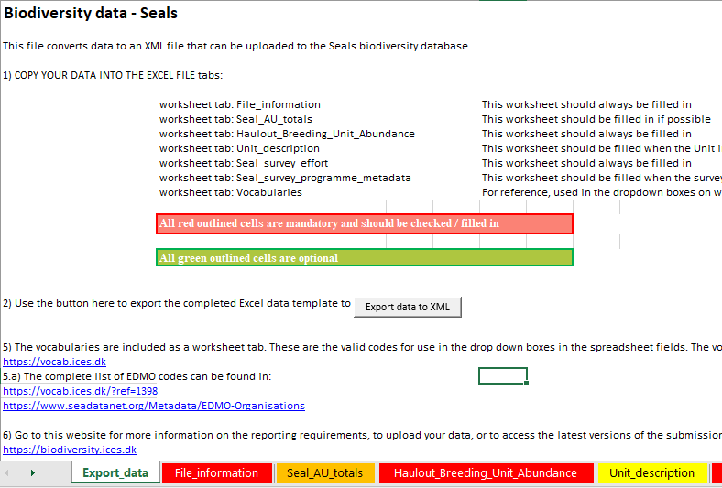
Figure 2. Excel sheet with the button for XML export.

Step 3: The XML file should then be uploaded to the ICES website (http://biodiversity.ices.dk/ManageSeals).
Login
A login is required in order to upload and manage data. The ICES sharepoint login can be used, if you do not have an ICES login please contact accessions@ices.dk

During data submission, data will be checked for correct use of vocabulary codes and data types. This quality control will ensure that the data standards have been met, a report of control issues will be generated and made available to the submitter online. Data not complying with the correct format will not be accepted by the uploading utility.

The Excel worksheets are described on the following pages. Fields marked in red are mandatory whereas fields marked in green are optional. The sheets [File_information], [Seal_AU_totals], [Haulout_breeding_unit_abundance] and [Seal_survey_effort] are the actual data tables that are to be submitted every year, whereas the worksheets [Unit_description] and [Seal_survey_programme_metadata] are reference tables that are filled out initially, and only updated when changes occur.
Some fields have specific ‘fixed’ values that need to be entered. These values are contained in the sheet ‘Vocabularies’ included with the Excel data entry sheets.
Data Access
OSPAR is committed to making as much information as possible publicly available, consistent with achieving other similarly important goals of public policy. The framework for this is set out in Article 9 of the OSPAR Convention and Annex 3 of the OSPAR Rules of Procedure (2013-2).
Contracting Parties should contact Chris Moulton (chris.moulton@ospar.org) if they have any queries over what data to include in the submissions.
Data access can be specified by the submitters directly in the submission form as:
Public Data are sourced outside the terms of the OSPAR data policy and are publicly accessible
Restricted Data, in their reported form, are not to be made publicly accessible. All aggregated data products are, by default, publicly available, including those derived from restricted data
Data will be made available in line with the terms of the OSPAR Data Policy where they are not restricted: https://odims.ospar.org/data_policy.html

Table 1. File information
Column Header | Optional / mandatory | Format Example | Explanation
Country | Mandatory | SE | ISO 3166 Code (2 ALPHA)  (Vocabulary)
Reporting_organisation | Mandatory | 3512 | EDMO code lookup  (Vocabulary)
Contact | Mandatory | Jon Smitsson | Name or email for point of contact for data submission (person who can direct queries to relevant survey co-ordinator or data manager)

Table 2. Seal AU Totals
Column Header | Optional / mandatory | Format Example | Explanation
Species_name | Mandatory | Phoca vitulina | Scientific name, according to the World Register of Marine Species (WoRMS) – www.marinespecies.org  Vocabulary: Phoca vitulina (harbour seal); Halichoerus grypus (Atlantic grey seal)
Focal_year | Mandatory | 1989 | This year which the data most pertains to. If the AU is covered in a single year, this is the survey year. If providing an AU total derived from incomplete surveys over multiple years this should be the year which you think best represents these data.
Start_year | Optional | 1987 | Please include a row for each year from 1980 (or earliest year) to 2019. Enter different start and end years if providing an AU total derived from incomplete surveys over multiple years.
End_year | Optional | 1989 | Enter different start and end years if providing an AU total derived from incomplete surveys over multiple years.
Seal_assessment_unit | Mandatory | 20 | Refer to Figure 1.  Vocabulary: 1, 2……25.
PARAM | Mandatory | Pup count | Vocabulary: pup count (all); adult/juvenile count; total count (all ages); pup production.
Value | Mandatory | 400 | Number of individuals or pups; or pup production
Estimate_type | Mandatory | Count on single day | Type of abundance estimation  Vocabulary: modelled estimate; count on single day; count over multiple days; counts over multiple years; maximum; average
Activity_type | Mandatory | GSM | Activity within the unit related to the species being reported, i.e. moult or breeding counts for harbour seal, and summer, breeding or moult counts for grey seal.  Vocabulary: moult; breeding; summer.
Survey_start_month | Optional | 03 | Start month of the survey, MM
Survey_end_month | Optional | 06 | End month of the survey, MM
Survey_programmeID | Mandatory | 1 | This is a unique identifier that provides links to Table 6 - Survey_programme_metadata
Data_access | Mandatory | Public | Indicates if data are public or restricted  “Public” for data that are publicly accessible  “Restricted” if data, in their reported form, are not to be made publicly accessible. All aggregated data products are, by default, publicly available, including those derived from restricted data

Table 3. Haulout_Breeding Unit Abundance
Column Header | Optional / mandatory | Format Example | Explanation
Species_name | Mandatory | Phoca vitulina | Scientific name, according to the World Register of Marine Species (WoRMS) – www.marinespecies.org  Vocabulary: Phoca vitulina (harbour seal); Halichoerus grypus (Atlantic grey seal)
Year | Mandatory | 1987 | The year that the reported data applies to. Please include a row for each year from 1980 to 2019.
Date | Optional (mandatory for pup counts only) | 20160921 | The date (yyyymmdd) count was made. Mandatory for pup counts, optional for all others.
UnitID | Mandatory | 4427 | A national unique numerical identifier for each unit (used to link to Table 4 – Haulout_breeding_unit_description). Allow for multiple entries of a unit in the same year if multiple counts available.
PARAM | Mandatory | Pup count (all) | Vocabulary: pup count (all); pup count (whitecoat); pup count (moulted pups); pup count (dead pups); pup count (other categories); adult/juvenile count; total count (all ages); pup production. Please note if dead pups are included separately, they should not be included in whitecoat or moulted pups.
Value | Mandatory | 400 | Number of adults or pups; or pup production
Estimate_type | Mandatory | single count | Type of abundance estimation  Vocabulary: modelled estimate; single count
Activity_type | Mandatory | GSM | Activity within the unit related to the species being reported, i.e. moult or breeding counts for harbour seal, and summer, breeding or moult counts for grey seal.  Vocabulary: moult; breeding; summer.
Survey_start_month | Optional | 03 | Start month of the survey, MM
Survey_end_month | Optional | 06 | End month of the survey, MM
SurveyID | Mandatory | 1 | This is a unique identifier that provides links to Table 5 - Seal_survey_effort
Survey_programmeID | Mandatory | 1 | This is a unique identifier that provides links to Table 6 - Seal_survey_programme_metadata
Data_access | Mandatory | Public | Indicates if data are public or restricted  “Public” for data that are publicly accessible;  “Restricted” if data, in their reported form, are not to be made publicly accessible. All aggregated data products are, by default, publicly available, including those derived from restricted data;

Table 4. Unit_description (for haulout / breeding units)
Column Header | Optional / mandatory | Format Example | Explanation
UnitID | Mandatory | 4427 | A national unique numerical identifier for each count site (used to link to Table 3 – Haulout_Breeding Unit_Abundance).
Unit_name | Optional | Lazy Sandbank | free text
Unit_type | Mandatory | Breeding unit | Vocabulary: breeding unit, haulout unit
Geometry_type | Mandatory | Point | Vocabulary: point; line; polygon
Latitude | Optional | 61.36 | If providing point data.  WGS84, decimal degrees
Longitude | Optional | -6.97 | If providing point data.  WGS84, decimal degrees
Polygon | Optional | { “type”: “Feature”,  “geometry”: {  “type”: “LineString”,  “coordinates”: [  [102.0, 0.0], [103.0, 1.0], [104.0, 0.0], [105.0, 1.0]  ]  },  “properties”: {  “prop0”: “value0”,  “prop1”: 0.0  }  } | Define the polygon using GeoJSON (http://geojson.org/)  WGS84, decimal degrees
Area_type | Optional | OSPARRegion | Area reference type.  Vocabulary: OSPARRegion
Area_reference | Optional | 2 | Vocabulary: 1 = Arctic Waters, 2 = Greater North Sea, 3 = Celtic Seas, 4 = Bay of Biscay and Iberian Coast, 5 = Wider Atlantic
Seal_assessment_unit | Mandatory | 20 | Refer to Figure 1.  Vocabulary: 1, 2……25.

Table 5. Seal_Survey_Effort
Column Header | Optional / mandatory | Format Example | Explanation
SurveyID | Mandatory | A | Use a unique identifier that provides link to the survey for which data is being provided as per Table 3 – Haulout/breeding unit Abundance. One row show be provided by survey round. E.g. one per duplicate moult survey in a given year
Survey_programmeID | Mandatory | 1 | This is a unique identifier that provides links to Table 6 – Seal_survey_programme  _metadata
PlatformClass | Mandatory | Land | Please fill out the survey platform, use only one option per cell.  Vocabulary: aerial, boat, land (ICES accepted vocabulary)
Count_method | Mandatory | Observed | Please fill out the count method, use only one option per cell.  Vocabulary: observed, photo
Start Date | Mandatory | 20160821 | Date which the survey started on
End Date | Mandatory | 20160825 | Date which the survey ended on
Data_resolution | Mandatory | Haulout units | Please fill out the resolution for the data being provided. Spatial effort data supplied as a polygon or multipolygon is required if M3 data is not supplied on a 5 x 5 km grid. M5 grey seal pup data and M3 data supplied on a 5 x 5 km grid do not require spatial effort data.  Vocabulary: haulout units, breeding units, 5km-grid
Data_type | Mandatory | Presence only | Please select one option for data type to describe the survey effort.  Vocabulary: Presence&absence, presence only
Geometry_type | Optional | Polygon | Effort data supplied as a polygon or multipolygon is required if M3 data is not supplied on a 5 x 5 km grid. M5 grey seal pup data and M3 data supplied on a 5 x 5 km grid do not require a polygon, so the field can be left blank.  Vocabulary: polygon, multipolygon.
Polygon | Optional | { “type”: “Feature”,  “geometry”: {  “type”: “LineString”,  “coordinates”: [  [102.0, 0.0], [103.0, 1.0], [104.0, 0.0], [105.0, 1.0]  ]  },  “properties”: {  “prop0”: “value0”,  “prop1”: 0.0  }  } | Define the polygon or multipolygon covered using GeoJSON (http://geojson.org/)  WGS84, decimal degrees

Table 6. Seal_survey_programme_metadata
Column Header | Optional / mandatory | Format Example | Explanation
Survey_programmeID | Mandatory | 1 | Use a unique identifier that provides link to the survey programme for which data is being provided as per Table 2 – Seal_AU_totals or Table 3 – Haulout_Breeding Unit_Abundance or Table 5 – Seal_survey_effort
Programme_name | Mandatory | Seals Monitoring Programme (SMP) | Full name of survey with abbreviation in parentheses.
Start_year | Mandatory | 1986 | Enter the year the survey started.
End_year | Optional | 2005 | Enter the year the survey ended. If the survey is ongoing, please leave blank.
Country | Mandatory | SE | ISO 3166 Code (2 ALPHA) – see Vocabulary. Enter one country only per cell.
Institute | Mandatory | “3512” for The Swedish Agency for Marine and Water Management | Data monitoring organisation. EDMO code lookup (Vocabulary)
Contact | Optional | Jon Smitsson | Point of contact for survey (e.g. co-ordinator or data manager).
Website | Optional | www.slu.se/en/seals | Website dedicated to survey (or survey protocol) if available.
Survey_protocol | Optional | Counts are usually conducted between 10:00 and 16:00 (local time) within 2 hours of low tide in dry weather | Free text  Please add additional information on survey protocol (e.g. counts are usually conducted between 10:00 and 16:00 (local time) within x hours of low tide in dry weather).
References | Optional | Smitsson et al (2012) | Any relevant references that describe methods and/or results.

Annex 1. Current and known plans for monitoring harbour seals during the moult in the OSPAR area (adapted and updated from ICES 2014b).
Country | MSFD assessment unit | Monitoring method | Comments
Ireland | Entire coast | Single aerial survey, approximately every 6 years | Three such surveys to date (2003, 2011-2012, 2017-2018)
Ireland | East and Southeast Ireland | Aerial survey of known moult sites | Commenced in 2013 on an annual basis. Data yet to be analysed.
Ireland | Southwest Ireland | Combination of boat-based and ground-based counts of key sites | Began in 2009. Efforts mainly centred on SACs for the species
Ireland | West Ireland | Combination of ground-based and boat-based counts of key sites | Began in 2009. Mainly ground-based counts. Efforts mainly centred on SACs for the species
Ireland | Northwest Ireland (not formalised within MSFD and under review) | Ground-based counts of key sites | Began in 2009. Efforts mainly centred on SACs for the species
United Kingdom | Shetland | Single aerial survey, approximately every five years. | _
United Kingdom | Orkney and North Coast | Single aerial survey, approximately every five years. | _
United Kingdom | Moray Firth | Repeat annual aerial survey for part of the Moray Firth | _
United Kingdom | East coast Scotland | Single aerial survey, approximately every five years. Single annual aerial survey in Firth of Tay. | _
United Kingdom | Southeast England | Repeat annual aerial survey. | _
United Kingdom | Southwest Scotland | Single aerial survey, approximately every five years. | _
United Kingdom | West Scotland | Single aerial survey, approximately every five years. | _
United Kingdom | Western Isles | Single aerial survey, approximately every five years | _
United Kingdom | Northern Ireland |  | No formal monitoring programme in place yet for Irish section but is currently under consideration.
Netherlands3 | Wadden Sea, Dutch Delta | Wadden Sea and Dutch Delta: Repeat annual aerial survey. | Monitoring also undertaken during pupping.
Germany3 | North Sea: Wadden Sea (Lower Saxony/Hamburg, Schleswig–Holstein) | Aerial survey conducted five times per year from June to August. | Monitoring also undertaken during pupping.
Germany3 | North Sea: Helgoland | Daily land counts | Since 2016. Monitoring also undertaken during pupping.
Denmark3 | North Sea: Wadden Sea | Repeat annual aerial survey (two flights). | One survey also undertaken during pupping.
Denmark3 | North Sea: Limfjord | Repeat annual aerial survey (two flights). | One survey also undertaken during pupping.
Norway/Sweden | Skagerrak and Oslo Fjord | Annual aerial survey (Skagerrak East coast: three flights within two-week moult survey season by Sweden). | _
Denmark/Sweden | Baltic Sea: Kattegat | Repeat annual aerial survey (two flights in Denmark, three flights in Sweden, within the two week moult survey period). Breeding only monitored in Denmark. | Monitoring also undertaken during pupping.
Denmark/Sweden | Baltic Sea: Belt seas | Repeat annual aerial survey (two flights).
Norway | West coast, south of 62°N | Aerial survey, every five years. | _
France | French North Sea and Channel coasts | Baie du Mont Saint Michel – aerial surveys, 18 per year + 15 census (boat and land). | Monitoring also undertaken during pupping.
France | Baie de Somme and adjacent haul-outs | Land census every ten days (January–June). Daily from June to September | _
France | Baie des Veys. | Monthly land and aerial surveys | _

Annex 2. Current and known plans for monitoring grey seals during pupping in the OSPAR area (adapted and updated from ICES 2014b).
Country | MSFD assessment unit | Monitoring method | Comments
Ireland | East and Southeast Ireland | Aerial surveys on rotational basis, each surveyed at least once within a 6-year cycle | Principal breeding colonies covered, 5-6 replicate surveys during the season
Ireland | Southwest and West Ireland | Aerial surveys on rotational basis, each surveyed at least once within a 6-year cycle | Principal breeding colonies covered, 5-6 replicate surveys during the season
Ireland | Northwest Ireland (not formalised within MSFD and under review) | Aerial surveys on rotational basis, each surveyed at least once within a 6-year cycle | Principal breeding colonies covered, 5-6 replicate surveys during the season
United Kingdom | Celtic Sea: West Scotland | Annual aerial survey until 2010, biennial thereafter. | _
United Kingdom | Celtic Sea: Western Isles, Scotland | Annual aerial survey until 2010,  biennial thereafter. | _
United Kingdom | Celtic Sea: Welsh coasts and Southwest England | Ground counts in caves or from cliff tops. | Pup counts in caves is difficult to undertake.
United Kingdom | North Sea: Shetland, Scotland | Annual ground count since 2004. | Difficult area to monitor.
United Kingdom | North Sea: Orkney, Scotland | Annual aerial survey until 2010, biennial thereafter. | _
United Kingdom | North Sea: Fast Castle,  Isle of May and adjacent colonies, Scotland | Annual aerial survey until 2010, biennial thereafter. | _
United Kingdom | North Sea: Moray Firth, east Scotland | Irregular until 2010, biennial thereafter. | _
United Kingdom | North Sea: Farne Islands, East England | Annual ground count. | _
United Kingdom | North Sea: Donna Nook and Norfolk colonies, Southeast England | Annual ground count. | _
Netherlands | North Sea: Wadden Sea | Aerial survey conducted five times per year from November to March/April. | Moult counts are also undertaken as pup counts are considered unreliable and not appropriate to population estimates (see Annex 3).
Netherlands3 | North Sea: Delta | Monthly aerial survey. | _
Germany3 | North Sea: Wadden Sea (Lower Saxony/Hamburg, Schleswig–Holstein) | Aerial survey conducted five times per year from November to March/April.  For Lower Saxony/Hamburg, grey seal pup counts restricted to the main pupping colony since winter 2017/2018 | Moult counts are also undertaken as pup counts are considered unreliable and not appropriate to population estimates (see Annex 3).
Germany3 | North Sea: Helgoland | Daily land counts since 2016. | Moult counts are also undertaken as pup counts are considered unreliable and not appropriate to population estimates (see Annex 3).
Denmark3 | North Sea: Wadden Sea | Replicate annual aerial survey (3 flights). | Moult counts are also undertaken as pup counts are considered unreliable and not appropriate to population estimates (see Annex 3).
Denmark3 | North Sea: Limfjord | Repeated annual aerial survey. | Summer counts undertaken during monitoring of harbour seal moult.
Denmark | North Sea: Kattegat | Annual aerial survey. | North Sea grey seals also occur in this area; as their moult coincides with the breeding of Baltic grey seals, this season is also covered, although seals from the two assessment units cannot be distinguished
Norway | North Sea: Rogaland | Ground count, every five years at least. | _
France | North Sea: Archipelago of Sept Îles and adjacent haul-outs | Regular (monthly) census and photo identification. | Pup counts are not appropriate to population estimates (low numbers).
France | North Sea: Archipelago of Molene and adjacent haul-outs | Regular (monthly) census and photo identification. | Pup counts are not appropriate to population estimates (low numbers).
France | North Sea: Baie de Somme and adjacent haul-outs | Regular (monthly) census and photo identification. | Pup counts are not appropriate to population estimates (low numbers).

Annex 3. Current and known plans for other grey seals monitoring (during moult or at other times of the year).
Country | MSFD assessment unit | Monitoring method | Comments
Germany | North Sea: Wadden Sea (Lower Saxony/Hamburg, Schleswig–Holstein) | Aerial survey conducted five times per year from November to March/April. | Dedicated moult survey for grey seals in spring
Germany | North Sea: Wadden Sea (Lower Saxony/Hamburg, Schleswig–Holstein) | Aerial survey conducted five times per year from November to March/April. | During moult survey for harbour seals (i.e. August)
Germany | North Sea: Helgoland | Daily land counts since 2016. | Dedicated moult survey for grey seals in spring
Germany | North Sea: Helgoland | Daily land counts since 2016. | During moult survey for harbour seals (i.e. August)
Denmark | North Sea: Wadden Sea | Aerial survey conducted five times per year from November to March/April. | Dedicated moult survey for grey seals in spring
Denmark | Kattegat | Aerial survey conducted 3 times during the Baltic grey seal pupping and moulting seasons (2 surveys for pups, 1 for moulting seals). | Dedicated moult survey for grey seals in May-June
Sweden | Skagerrak & Kattegat | Grey seals counted during harbour seal surveys (three flights in latter half of August)

Annex 4. Glossary.
Unit refers to the spatial scale at which data are provided, i.e. assessment unit, haulout unit or breeding unit, and is defined throughout.
Haulout unit is an arbitrary unit which can represent part of what may biologically considered a haulout (e.g. a count associated with the location of an individual photograph), a haul out or a cluster of haulouts. Haulout units for which the spatial extent is < c. 2.5 km can be input as Points. Polygons should reflect the approximate extent of haulouts/clusters and can be used instead of points for any haulout unit but must be used for any haulout units which are >2.5 km in spatial extent.
Breeding unit refers to a grey seal breeding colony(ies) on which pup counts and pup production estimates are provided. Irrespective of spatial extent, such colonies can be represented by points or polygons and must be identifiable (i.e. consistent) between surveys.
Survey ID is a unique identifier that provides a link to the survey effort for which haulout unit or breeding unit abundance data is being provided.
Survey programme ID is a unique identifier for the survey programme, that provides a link between survey programme metadata, survey effort and the AU, haulout unit or breeding unit abundance data that is being provided.

Coordinated monitoring under TMAP (Trilateral Monitoring and Assessment Programme), coordinated by EG-Seals (Trilateral Seal Expert Group); http://www.waddensea-secretariat.org/monitoring-tmap/topics/marine-mammals

